SmartSpend - Smart Expense Manager &Splitwise Clone

MCA Final Year Project Report



J D College of Engineering and Management, Nagpur-441501
Near Hanuman Temple, Borgoan Phata, Kalmeshwar Road,
Nagpur -441501
(An Autonomous Institute, with NAAC “A” Grade)
www.jdcoem.ac.in
Affiliated to DBATU, RTMNU & MSBTE Mumbai.

PROJECT REPORT

The arrangement of parts of the MCA Final Year Project Report
The sequence in which the project report material should be arranged and bound should be as follows:
- Cover page
- Inside cover page
- Declaration Page
- Certificate
- Certificate of Approval
- Index
- Acknowledgement
- List of Figures
- List of Tables
- Abbreviations and Symbols
- Abstract
- All Chapters
- References
- Annexure
- List of papers published based on the project
- Copyright certificate
- NPTEL Elite certificate
- Plagiarism Report
- Grammarly Report
- Photo Gallery
- Bibliography
The Sample Templates are given below

Templates |  | Page Number
Cover page | See Template 1 | 4
Inside cover page | See Template 2 | 5
Declaration | See Template 3 | 6
Certificate | See Template 4 | 7
Certificate of Approval | See Template 5 | 8
Index | See Template 6 | 9
Contents at a Glance | See Template 6 | 9-10
Acknowledgement | See Template 7  Should not exceed one page | 10
List of Figures | See Template 8 | 12
List of Tables | See Template 9 | 13
Abbreviations and Symbols | See Template 10 | 14
Abstract | See Template 11 | 15
References | See Template 12 | 22
ANNEXURES
Paper Published | Annexure I | 23-24
Copyright certificate | Annexure II | 25
NPTEL Elite certificate | Annexure III | 26
Plagiarism Report | Annexure IV | 27
Grammarly Report | Annexure V | 28
Photo Gallery | Annexure VI | 29
Bibliography | Annexure VII | 30
Binding Details | (Only for information. Not to be included in Project Report) | 31

Roman numerals should be given to pages from Template 5 to Template 11



SmartSpend - Smart Expense Manager & Splitwise Clone

A Project Report submitted in partial fulfillment of the requirements for the award of the degree of
Master of Computer Applications
Submitted by
Adesh Gautam Lokhande
MC250005CA

Under the Guidance of Dr. Swati Adekar

Master of Computer Applications
J D College of Engineering and Management, Nagpur-441501
(An Autonomous Institute, with NAAC “A” Grade)
Affiliated to DBATU, RTMNU & MSBTE Mumbai.
Year 2026-27

SmartSpend - Smart Expense Manager & Splitwise Clone

A Project Report submitted in partial fulfilment of the requirements for the award of the degree of

Master of Computer Applications

Submitted by
Adesh Gautam Lokhande
MC250005CA

Under the Guidance of
Dr. Swati Adekar

Master of Computer Applications

J D College of Engineering and Management, Nagpur-441501
(An Autonomous Institute, with NAAC “A” Grade)
Affiliated to DBATU. RTMNU & MSBTE, Mumbai.
Year 2026-27
DECLARATION
(Font: Times New Roman, Size: 14)

We hereby declare that the work presented in this project report entitled “SmartSpend - Smart Expense Manager & Splitwise Clone” in the subject Computer Applications in the Faculty of Science and Technology is the original contribution carried out by us under the guidance of Dr Swati Adekar, Department of Computer Applications, J D College of Engineering and Management, Nagpur. This work has not been submitted to any other University or Institution for the award of any degree or diploma or certificate course.

Place: Name of Student/Students
Date:

CERTIFICATE
(Font: Times New Roman, Size: 14)

This is to certify that the project report entitled “SmartSpend - Smart Expense Manager & Splitwise Clone” in the subject Computer Applications in the Faculty of Science and Technology, submitted by Adesh Gautam Lokhande to Dr Babasaheb Ambedkar Technological University, Lonere, for the award of the degree of Master of Computer Applications, is a bona fide record of work carried out by them under my supervision. The contents of this Project Report, in full or in parts, have not been submitted or published to any other Institute or University for the award of any degree or diploma.

(Dr. Swati Adekar)
MCA

Forwarded to:

Prof.
Project Coordinator

Prof. Swati S. Adekar
Head of the Department
CA

Dr. S. V. Sonekar
Principal

CERTIFICATE OF APPROVAL

This is to certify that the Project Report on SmartSpend - Smart Expense Manager & Splitwise Clone is an approved work done by Adesh Gautam Lokhande in partial fulfilment of the requirements for the award of the degree of Master of Computer Applications at J D College of Engineering & Management, Nagpur, affiliated to Dr Babasaheb Ambedkar Technological University, Lonere, during the academic year 2026-27.

Name of Guide Prof. Swati S. Adekar
Guide Head of the Department

_ _ _

Project Examination held on

Internal Examiner/ Guide External Examiner

 | INDEX
Title |  | Page No.
Acknowledgement |  | i
List of Figures |  | ii
List of Tables |  | iii
Abbreviations and Symbols |  | iv
Abstract |  | v

CONTENTS AT A GLANCE

Title Page No.
Chapter 1 INTRODUCTION
  - Brief Outline of Project
  - Overview of Project Report

Chapter 2 LITERATURE SURVEY
  - Literature Review
  - Research Gap
  - Problem Statement
  - Objectives

Chapter 3 RESEARCH METHODOLOGY
  - Sub-Section 1
    - Sub-Sub-Section
  - Sub-Section 2

Chapter 4 EXPERIMENTATION/ IMPLEMENTATION/ SIMULATION
  - Sub-Section 1
3.1.1 Sub-Sub-Section
  - Sub-Section 2

Chapter 5 RESULTS AND DISCUSSIONS Chapter 6 SUMMARY AND CONCLUSION
  - Summary
  - Conclusion
  - Scope for Future Work

REFERENCES ANNEXURES
Paper published
Copyright Certificate
NPTEL Elite Certificate
Plagiarism Report
Grammarly Report
Photo Gallery
Bibliography

ACKNOWLEDEMENT
(Font: Times New Roman, Size: 14)

We express our sincere gratitude for giving us the opportunity to work on the project during our final year of MCA.
We owe our sincerest gratitude towards Dr S. V. Sonekar, Principal, J D College of Engineering & Management, Nagpur, for providing the platform and necessary facilities.
The constant guidance and encouragement received from Prof. Swati S. Adekar, Head, Department of Computer Applications, J D College of Engineering & Management, Nagpur, have been of great help in carrying out the project work and are acknowledged with reverential thanks.
We would like to thank Dr. Swati Adekar, Project Coordinator, J D College of Engineering & Management, Nagpur, for providing proper guidelines and continuous efforts taken towards the completion of the project.
We would like to express a deep sense of gratitude and thanks profusely to our Guide, Dr Swati Adekar, Department of Computer Applications, J D College of Engineering & Management, Nagpur. Without his/her wise counsel and able guidance, it would have been impossible to complete the project in this manner.
We would like to thank the members of the Departmental Research Committee for their valuable suggestions and healthy criticism during our presentation of the work. We express gratitude to other faculty members of the Computer Applications Department, J D College of Engineering & Management, Nagpur, for their intellectual support throughout the course of this work.

Adesh Gautam Lokhande

LIST OF FIGURES

Figure No. | Title | Page No.
2.1 | Water/ Oil/ Water System
3.2 | Nature of Surfactant
4.1 | Extraction Mechanism- Type I
5.1 | Extraction Mechanism- Type II
5.2 | Structure of Span 80

LIST OF TABLES

Table No. | Title | Page No.
3.1 | Name of Table
3.2 | Name of Table
4.1 | Name of Table
5.1 | Name of Table

LIST OF ABBREVIATIONS
- AI Artificial Intelligence
- CSS Cascading Style Sheets
- DB Database
- DBMS Database Management System
- DFD Data Flow Diagram
- DOI Digital Object Identifier
- ER Entity-Relationship
- FinTech Financial Technology
- HTML HyperText Markup Language
- JS JavaScript
- MCA Master of Computer Applications
- PDF Portable Document Format
- SQL Structured Query Language
- UI User Interface
- UML Unified Modelling Language
- URL Uniform Resource Locator
- UX User Experience

LIST OF SYMBOLS
- ₹ Indian Rupee (Currency Symbol)
- % Percentage
- = Equal To
- + Addition
- − Subtraction
- × Multiplication
- / Division
- ( ) Parentheses (Grouping)
- : Ratio or Separation
- & And
- – Range or Connection Between Terms
- . Decimal Point or Full Stop

ABSTRACT

The SmartSpend - Smart Expense Manager & Splitwise Clone is a web-based application developed using technologies like Django or Node.js to simplify group expense management among friends, roommates, families, or teams. Manually managing shared expenses often creates confusion, calculation errors, and misunderstandings. This project provides an efficient digital solution for automatically tracking and splitting expenses.

The application allows users to create groups and add multiple members to manage shared expenses. Any group member can add expenses with details such as amount, description, payer name, and participants involved in the expense. The system automatically calculates the balance distribution and determines who owes money to whom. This reduces manual calculations and saves time for users.

One of the major features of the project is the auto balance calculation system, which continuously updates the financial status of each member whenever a new expense is added. The application also includes a settlement tracking feature that helps users record completed payments and maintain transparency within the group. Users can easily view pending balances, payment history, and overall expense summaries.

The Smart Expense Split App is designed with a simple and user-friendly interface so that users with basic technical knowledge can easily operate it. The project demonstrates the practical implementation of backend development, database management, authentication systems, and financial calculation logic. It also improves understanding of real-world web application development concepts.

Overall, the project aims to provide a smart, reliable, and organised platform for managing shared expenses efficiently while minimising conflicts and improving financial transparency among users

CHAPTER 1: INTRODUCTION

1. BRIEF OUTLINE OF PROJECT

1.1 Introduction
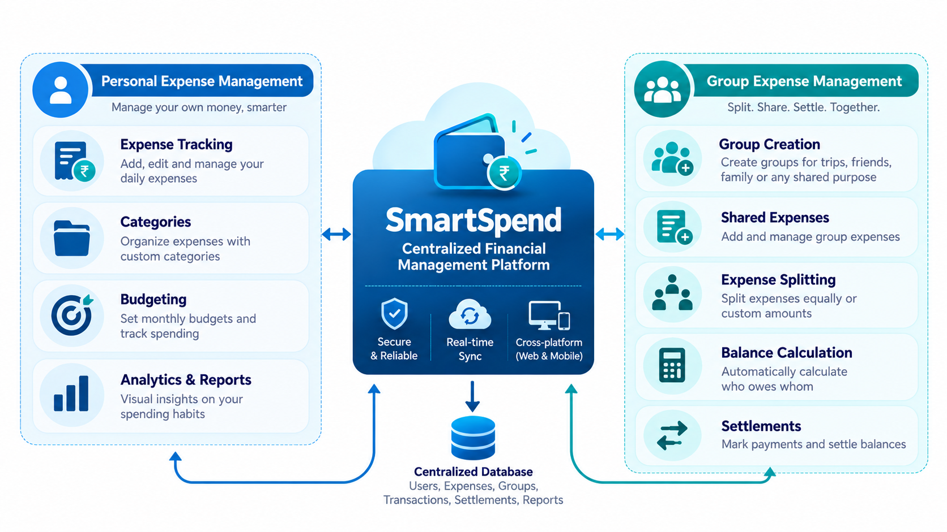
Financial management is an important part of everyday life. Individuals regularly spend money on food, transportation, shopping, education, entertainment, and other activities. Maintaining accurate expense records helps individuals understand their spending habits and manage their finances effectively. However, recording and tracking multiple transactions manually can be difficult and time-consuming.
Managing expenses becomes more complicated when multiple individuals share financial responsibilities. Friends, students, colleagues, and families often share expenses for accommodation, transportation, food, and other common activities. Calculating individual contributions and outstanding balances manually may lead to confusion and errors.
To address these challenges, SmartSpend – Smart Expense Manager & Splitwise Clone is developed as a web-based application that combines personal expense tracking and group expense management in a single platform.
The application allows users to record personal expenses, manage budgets, create groups, add members, record shared expenses, calculate individual contributions, and track settlements. It supports equal, custom, and percentage-based expense splitting methods.
SmartSpend also provides a dashboard for presenting summarised financial information through graphical representations. Its responsive interface incorporates an Apple Liquid Glass-inspired design with Dark Mode and Light Mode options.
The application uses Python and Django for backend development, HTML, CSS, JavaScript, and Bootstrap 5 for frontend development, MySQL for database management, and Chart.js for graphical visualisation.
The primary purpose of SmartSpend is to simplify financial management, reduce manual calculations, and provide users with an organised platform for handling personal and shared expenses.

1.2 Background of the Project
Traditional expense management methods commonly involve notebooks, spreadsheets, calculators, or separate applications. Although these methods can maintain financial records, they often require manual effort and do not provide an integrated solution for personal and shared expenses.
For example, when four friends travel together, different members may pay for accommodation, transportation, and food. At the end of the trip, they need to calculate the total expenditure and determine each person's financial responsibility. Repeated manual calculations can become difficult when several transactions are involved.
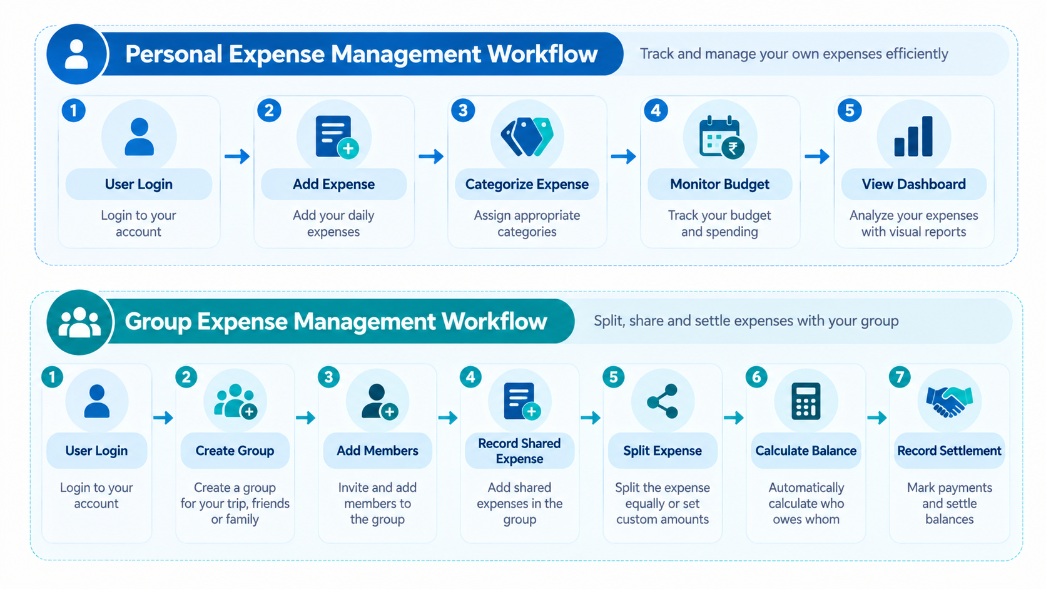
Digital expense management applications provide a more systematic approach by recording transactions and automating financial calculations.
SmartSpend is developed to combine two major financial management activities: personal expense tracking and group expense sharing. It provides a centralised environment where users can manage individual transactions while also participating in shared financial activities.

1.3 Need for the Project
The major reasons for developing SmartSpend are:
- Expense Tracking: Maintaining daily expense records manually can be difficult. The application provides organised digital expense records.
- Centralised Management: Users can manage personal and shared expenses through one platform.
- Expense Calculation: Automated splitting reduces the effort required to calculate individual contributions.
- Balance Tracking: Users can identify outstanding amounts between group members.
- Budget Monitoring: Budget management helps users compare actual expenditure against planned limits.
- Financial Awareness: Dashboard summaries and charts help users understand spending patterns.
- Transparency: Organised shared expense records help group members understand their financial responsibilities.

1.4 Aim of the Project
The main aim of SmartSpend is to develop a web-based application that simplifies personal and group expense management through centralised record-keeping, automated expense calculations, budget monitoring, and organised financial information.

1.5 Scope of the Project
The project focuses on the following functional areas:
- Authentication and Profile Management: Provides user login, registration, and profile-related functionality.
- Personal Expense Management: Allows users to add, view, update, delete, and categorise personal expenses.
- Group Management: Enables users to create groups and manage participating members.
- Group Invitations: Supports inviting users and managing group membership.
- Group Expense Management: Allows members to record expenses shared within a group.
- Expense Splitting: Supports equal, custom, and percentage-based expense distribution.
- Balance Calculation: Determines outstanding amounts based on recorded payments and assigned shares.
- Settlement Management: Maintains records of payments between group members.
- Dashboard and Analytics: Displays summarised financial information and graphical representations.
- Budget Management: Helps users monitor expenditure against predefined budgets.
- Search and Filters: Allows users to retrieve specific expense records.
- Administrative and Security Management: Supports application administration and controlled access to information.
The current project focuses on the functionalities implemented in the application. Additional features outside its existing scope are considered future enhancements.

1.6 Objectives of the Project
The major objectives of SmartSpend are:
- To develop a centralised web-based expense management application.
- To provide efficient personal expense tracking and categorisation.
- To enable users to create and manage expense-sharing groups.
- To implement multiple expense-splitting methods.
- To automate individual share and outstanding balance calculations.
- To provide settlement management facilities.
- To support budget monitoring and financial analytics.
- To implement search and filtering functionality.
- To provide appropriate authentication and access control.
- To develop a responsive interface with Dark Mode and Light Mode.

1.7 Proposed Solution
SmartSpend provides a unified platform for managing personal and shared financial activities. Users can record personal expenses independently and participate in groups for managing common expenses.
When a group expense is recorded, the application stores relevant information, including the amount, payer, description, and participating members. Based on the selected splitting method, individual shares are calculated and used to determine outstanding balances.
For example, an expense of ₹4,000 shared equally among four members results in a contribution of ₹1,000 per member. If one member pays the complete amount, the system calculates the remaining members' outstanding contributions.
The dashboard and budget management facilities provide additional support for monitoring financial activities.

1.8 Technology Overview
The application uses the following technologies:
Technology | Purpose
Python | Backend programming
Django 6.1 | Web application framework
MySQL | Database management
SQLite | Alternative database
HTML5, CSS3 | Page structure and styling
JavaScript | Client-side interactions
Bootstrap 5 | Responsive interface
Chart.js | Financial visualizations
Google Antigravity | AI-assisted development

1.9 Significance of the Project
SmartSpend combines personal financial tracking and group expense management within a single application. It reduces manual calculations, improves the organisation of financial records, and provides better visibility into individual and shared expenses.
The project also demonstrates the practical application of web development, database management, software engineering, authentication, and financial calculation concepts in solving real-world problems.

CHAPTER 2:LITERATURE SURVEY

2.1 LITERATURE REVIEW
A literature review is an important part of software development research because it provides information about existing systems, technologies, research studies, and methodologies related to the proposed application. It helps to understand the development of expense management solutions and identify areas where further improvements can be made.
Traditional financial management methods mainly depend on handwritten records, calculators, and spreadsheets. These approaches require manual calculations and continuous maintenance. With advancements in web and mobile technologies, digital expense management applications have introduced automated transaction recording, expense categorisation, budgeting, and financial analysis.
Savitha and Hawaldar (2022) studied the factors influencing individuals' adoption of FinTech budgeting applications. Their research highlighted the importance of user engagement, perceived trust, ease of use, financial awareness, and data visualisation in encouraging users to adopt digital budgeting solutions [1].
More and more web-based applications are being developed to simplify personal financial management. A study titled SpendWise – An Innovative Expense Tracking Webapp for Students (2023) discussed the requirements of an expense-tracking application designed to help students monitor expenditures, categorise transactions, and manage budgets [2].
Jha et al. (2025), in their research paper Design and Implementation of a Web-Based Expense Tracker System for Personal Finance Management, presented a web-based system for recording income and expenses, organising transactions, and displaying financial information through a dashboard [3].
Similarly, the research paper Finexa: A Personal Finance Management Web Application for Expense Tracking and Budgeting (2026) presented a web application supporting expense tracking, budget management, financial goals, and personalised financial guidance [4].
In the area of group expense management, Splitwise is a widely recognised application. It allows users to create groups, record shared expenses, calculate balances, and maintain settlement records. Its documentation describes different expense distribution methods, including equal splitting, exact amounts, and percentage-based splitting [5].
Another research work, Apportion: The Bill Split (2023), discussed a system designed to simplify the distribution of group expenses and reduce the difficulties associated with calculating individual financial responsibilities [6].
These studies and applications demonstrate the importance of automated financial calculations, organised transaction records, and user-friendly interfaces in modern expense management systems.

2.1.1 Comparison of Existing Systems
The following table presents a comparison of traditional approaches and existing digital expense management solutions.
System | Main Functionality | Identified Limitation
Manual Records | Recording daily expenses | Manual calculations and maintenance
Spreadsheets | Organising financial records | Requires manual updates
Personal Expense Trackers | Expense tracking and budgeting | Focuses mainly on individual finances
Splitwise | Group expense splitting and settlements | Primarily designed for shared expenses
SmartSpend | Personal and group expense management | Functionality depends on implemented modules
The literature review indicates that personal finance applications mainly focus on individual expenditure tracking, whereas group expense-sharing applications emphasise the distribution of common expenses and settlement calculations.
SmartSpend combines these two areas within a single web-based platform.

2.2 RESEARCH GAP
The study of existing expense management systems identifies several areas that provide opportunities for developing an integrated financial management application.
Many traditional methods require manual calculations and continuous record maintenance. Although digital applications reduce these difficulties, different applications may focus on specific financial management requirements.
Personal expense tracking systems generally emphasise transaction recording, categorisation, budget monitoring, and financial analysis. Group expense-sharing applications primarily focus on recording common expenses, calculating individual contributions, and managing settlements.
Based on the comparative analysis, the following areas are considered relevant research gaps for the proposed project:
- Separate Financial Management: Users may need different applications or methods to manage personal expenses and shared group expenses.
- Manual Calculation Difficulties: Calculating individual contributions and outstanding balances manually can become complicated when multiple transactions are involved.
- Limited Financial Overview: Maintaining personal and group financial information separately can make overall expense monitoring less convenient.
- Budget Monitoring Requirements: Users require organised facilities to monitor personal expenditures against predefined budgets.
- User Interface and Accessibility: Modern financial applications should provide responsive interfaces and flexible display options to improve usability.
- Centralised Record Management: Maintaining personal transactions, group expenses, and settlement information within a common platform can improve financial organisation.
SmartSpend addresses these identified requirements by integrating personal expense tracking, group expense sharing, budget management, balance calculation, and settlement management into one application.

2.3 PROBLEM STATEMENT
Managing personal and shared expenses is a common challenge for individuals and groups. Traditional expense management methods require manual transaction recording, calculations, and continuous maintenance of financial records.
When multiple individuals share expenses, determining each participant's contribution becomes more complicated. Different members may pay different amounts, and expenses may need to be distributed equally or according to specific amounts or percentages.
Manual calculations can result in errors, confusion, and difficulties in maintaining updated financial balances. Additionally, managing personal expenses, budgets, group transactions, and settlements through separate methods makes financial information difficult to organise.
Therefore, there is a need for a centralised web-based application that simplifies personal and group expense management, automates expense calculations, maintains financial records, and provides an organised interface for monitoring financial activities.
SmartSpend is proposed to address these problems through integrated expense tracking, flexible expense splitting, balance calculation, settlement management, and budget monitoring functionalities.

2.4 OBJECTIVES
The main objective of SmartSpend is to develop a centralised web-based application that simplifies personal and group expense management.
The specific objectives are:
- To develop a user-friendly web-based expense management application.
- To provide facilities for recording, updating, deleting, and categorising personal expenses.
- To enable users to create groups and manage group members.
- To provide functionality for recording shared group expenses.
- To implement equal, custom, and percentage-based expense-splitting methods.
- To automate the calculation of individual expense shares and outstanding balances.
- To provide settlement management facilities for recording payments between group members.
- To implement budget management for monitoring personal expenditures.
- To provide a dashboard for displaying summarised financial information and graphical analytics.
- To implement search and filtering facilities for efficient expense retrieval.
- To provide appropriate authentication and access control mechanisms.
- To develop a responsive interface with Dark Mode and Light Mode support.
These objectives establish the functional and technical direction of the SmartSpend project. The subsequent chapters explain the methodology, system design, implementation, and evaluation of the proposed application.

CHAPTER 3:RESEARCH METHODOLOGY

3.1 REQUIREMENT ANALYSIS
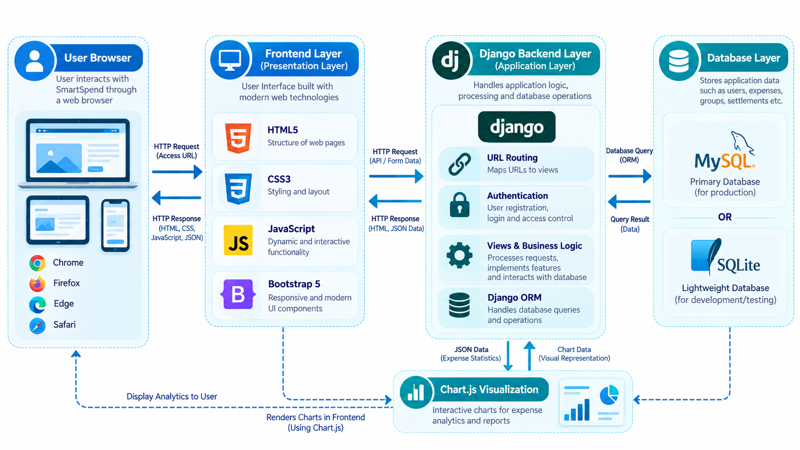

Requirement analysis is an important phase of software development in which the needs and expectations of the proposed system are identified and documented. It helps determine the functionalities, technical specifications, and operational requirements necessary for developing the application.

For SmartSpend, requirements analysis focuses on understanding the difficulties associated with personal expense tracking and group expense management. The requirements are identified according to the application's main functionalities, including expense recording, group management, expense splitting, balance calculation, settlement management, and budget monitoring.

The application is designed to provide a centralised platform where users can manage their individual financial activities and shared group expenses.

3.1.1 Functional and Non-Functional Requirements

A. Functional Requirements

Functional requirements describe the operations and services that the application provides to its users.

The major functional requirements of SmartSpend are:

User Authentication: The system allows users to register, log in, and access their accounts.

Profile Management: Users can manage their personal account information.

Personal Expense Management: Users can add, view, update, delete, and categorise personal expenses.

Group Management: Users can create groups and manage participating members.

Group Invitations: Users can invite other individuals to participate in expense-sharing groups.

Shared Expense Management: Group members can record expenses associated with their groups.

Expense Splitting: The application supports equal, custom, and percentage-based expense distribution.

Balance Calculation: The system calculates individual financial balances based on payments and assigned expense shares.

Settlement Management: Users can record payments between group members.

Dashboard and Analytics: The application displays summarised financial information through statistics and graphical representations.

Budget Management: Users can define budgets and monitor their expenditure.

Search and Filtering: Users can search and filter expense records to retrieve relevant information.

B. Non-Functional Requirements

Non-functional requirements describe the quality and operational characteristics expected from the application.

The major non-functional requirements are:

Security: The application should provide authentication, authorisation, and appropriate data protection.

Usability: The interface should be simple, consistent, and easy to navigate.

Performance: Common operations such as retrieving expenses and calculating balances should execute efficiently.

Reliability: Financial records should remain accurate, and database operations should be handled consistently.

Scalability: The application architecture should support future expansion of users and functionalities.

Responsiveness: The interface should adapt to desktops, tablets, and mobile devices.

Maintainability: The application should follow a structured development approach to simplify modifications.

Compatibility: The application should support commonly used modern web browsers.

3.2 SYSTEM DEVELOPMENT METHODOLOGY

SmartSpend follows a structured software development approach in which the application is developed through different stages, starting with requirement identification and continuing through design, implementation, and testing.

The development methodology focuses on dividing the application into manageable components and integrating them to create a complete expense management system.
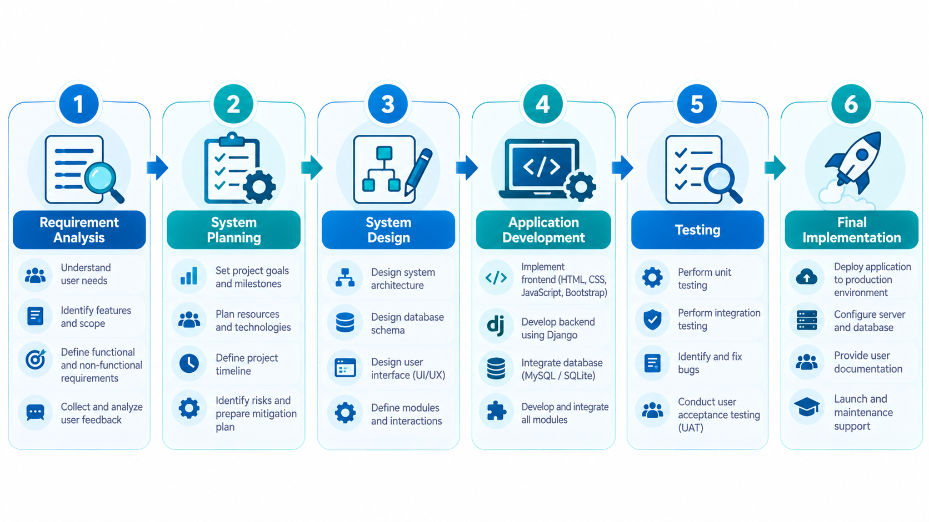

The major stages of development are described below.

1. Requirement Analysis

The first stage involves identifying the problems associated with personal and group expense management. Functional and non-functional requirements are defined to establish the application's scope and expected behaviour.

2. System Planning

During this stage, the application modules, technology stack, database requirements, and development priorities are identified. The system is divided into smaller functional components to simplify development and maintenance.

3. System Design

The system architecture and database structure are designed according to the identified requirements. Relationships between users, expenses, groups, members, and settlements are considered while planning the database.

4. Application Development

The backend is developed using Python and Django, while HTML, CSS, JavaScript, and Bootstrap 5 are used for frontend development. MySQL is used for structured data storage, with SQLite supported as an alternative database configuration.

5. Module Integration

Individual application components are integrated to provide complete functionality. Authentication, expense management, group management, calculations, dashboard operations, and other modules are connected through the application architecture.

6. Testing and Verification

The application is tested to verify its major functionalities, including expense recording, expense splitting, balance calculations, settlement operations, and user authentication. Errors identified during testing are addressed through appropriate modifications.

7. Final Implementation

After development and testing, the application is prepared for its intended execution environment. Its interface and functionalities are verified to ensure that the major project requirements are satisfied.

Google Antigravity is used as an AI-assisted development environment to support the development and implementation process.

The structured methodology helps maintain a systematic development process, organise application components, and ensure that the developed system addresses the identified requirements.

CHAPTER 4: EXPERIMENTATION / IMPLEMENTATION / SIMULATION

4.1 SYSTEM IMPLEMENTATION
System implementation is the process of converting the designed system into a functional software application. It involves developing individual modules, integrating different components, connecting the database, and implementing the required business logic.
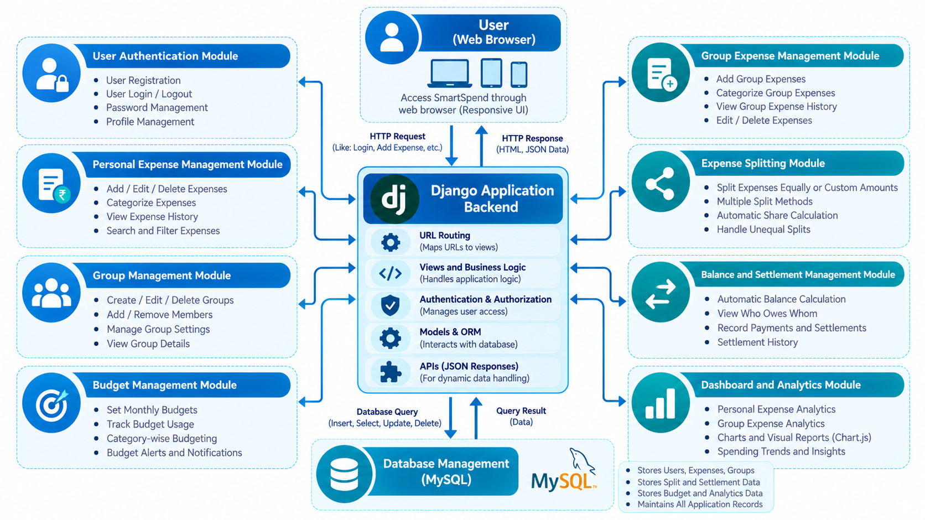
SmartSpend is implemented as a web-based application using Python and Django for backend development. HTML, CSS, JavaScript, and Bootstrap 5 are used to develop the frontend interface. MySQL is used for database management, with SQLite supported as an alternative configuration.
The application follows a modular development approach in which different functionalities are organised into separate components. This makes the application easier to maintain and extend.
The frontend communicates with the backend through the web application architecture. Django processes user requests, executes the required operations, interacts with the database, and returns the appropriate responses.
The implementation focuses on providing secure access, organised expense records, automated financial calculations, and an interactive user interface.

4.1.1 Implementation of Major Modules
The major modules implemented in SmartSpend are described below.
1. Authentication and Profile Management
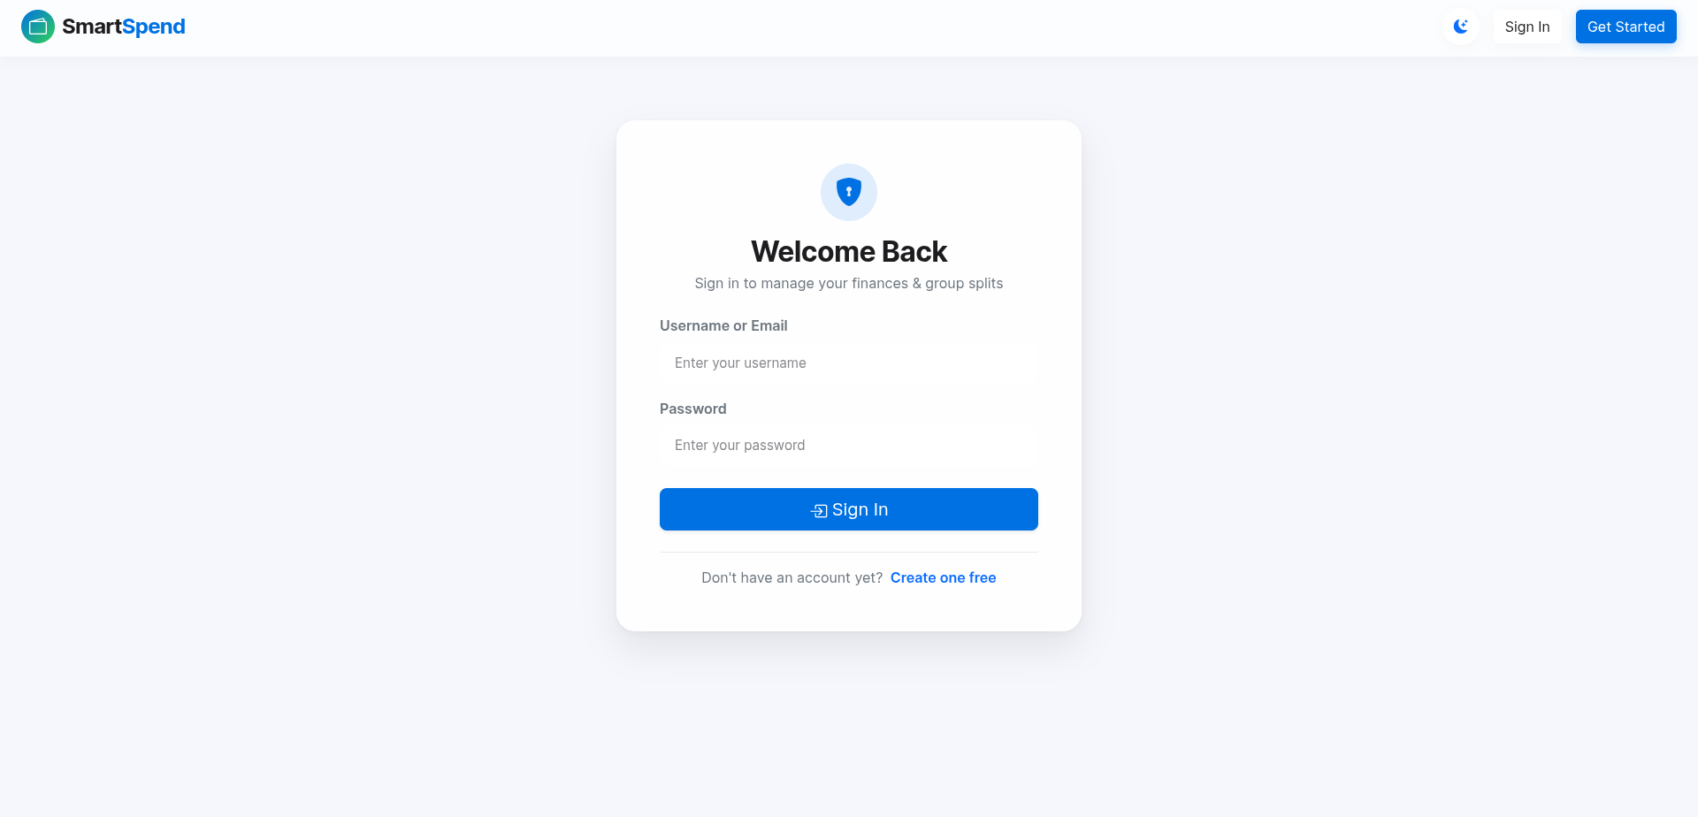
This module manages user access to the application. It provides registration and login functionality and maintains individual user accounts. Profile management allows users to maintain their account information.
2. Personal Expense Management
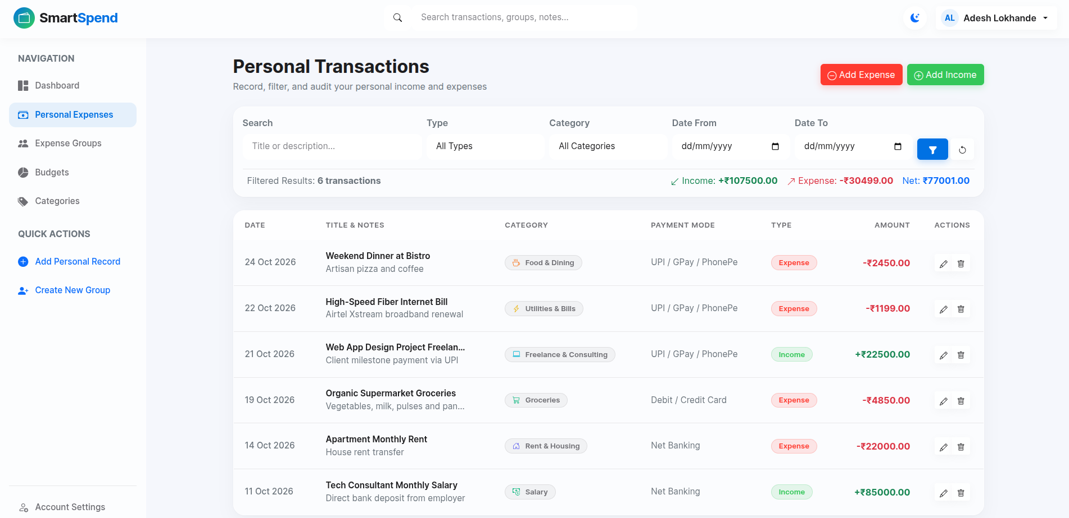
This module allows users to record and manage their personal expenses. Users can add new transactions, update existing records, delete unnecessary entries, and organise expenses using categories.
3. Group Management
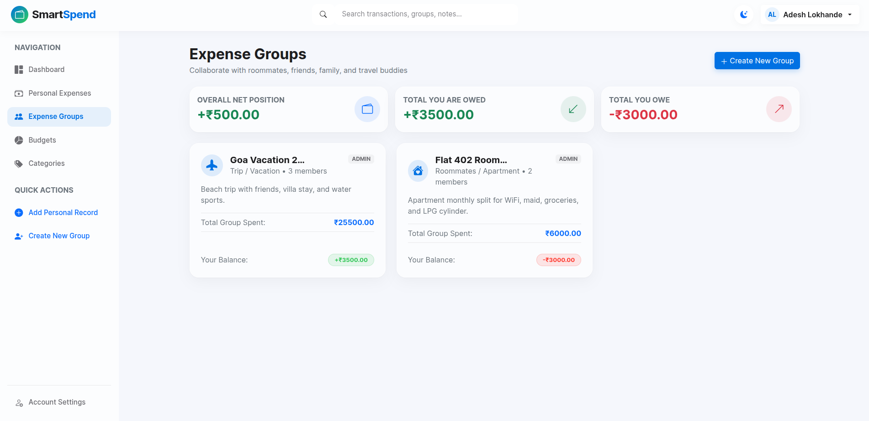
The group management module allows users to create groups for shared financial activities. Users can manage group details and add members who participate in common expenses.
4. Group Expense Management
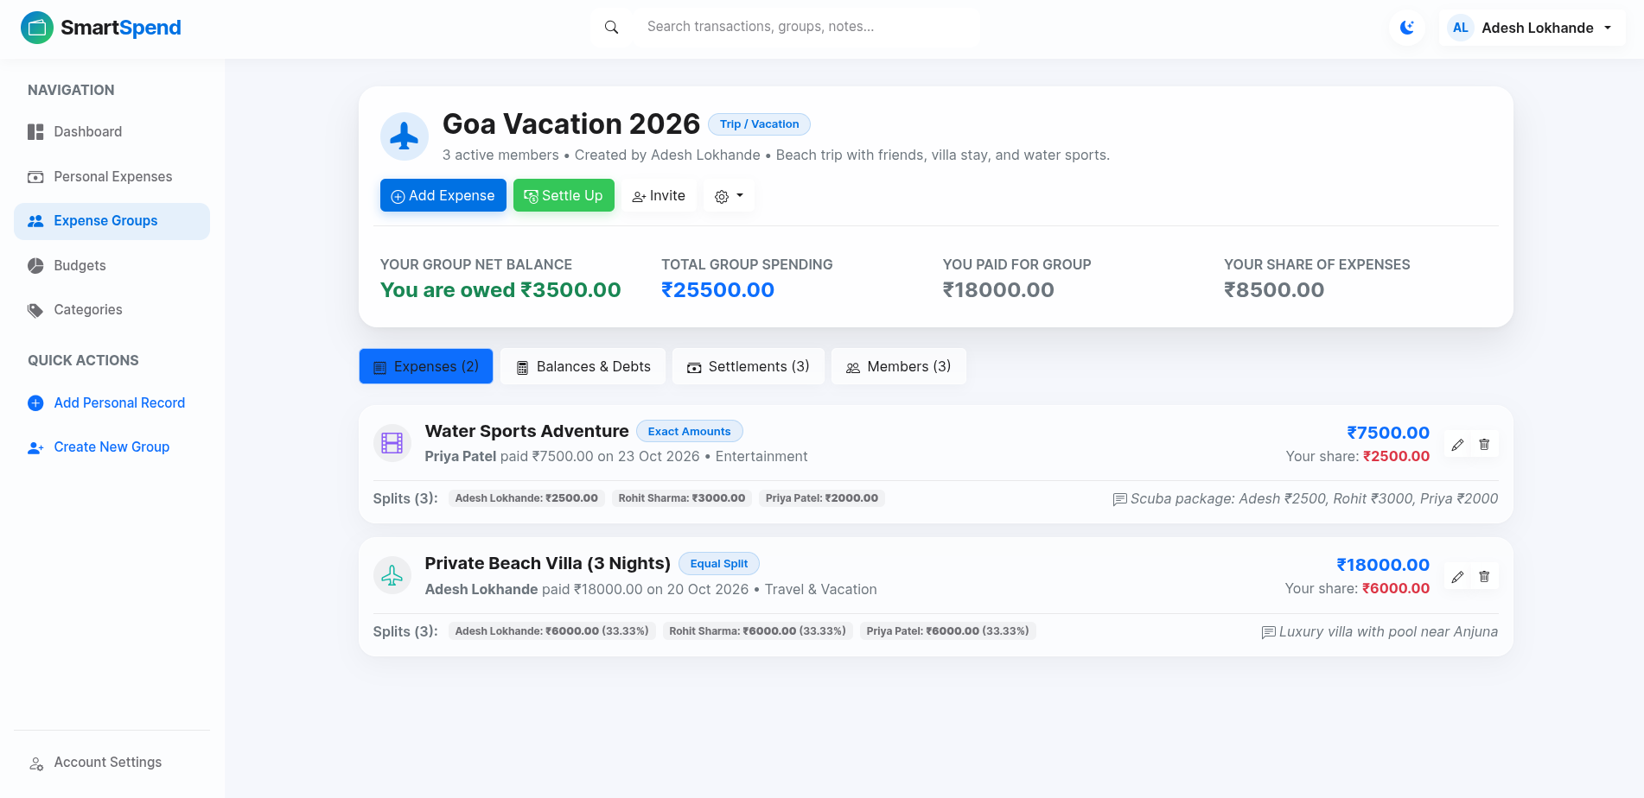
This module manages financial transactions recorded within groups. It maintains information about the expense amount, description, payer, date, and participating members.
5. Expense Splitting
The expense-splitting module distributes shared expenses among selected participants using three methods:
- Equal Splitting: Divides the total amount equally among participants.
- Custom Splitting: Assigns specific amounts to individual participants.
- Percentage-Based Splitting: Distributes expenses according to predefined percentages.
6. Balance and Settlement Management
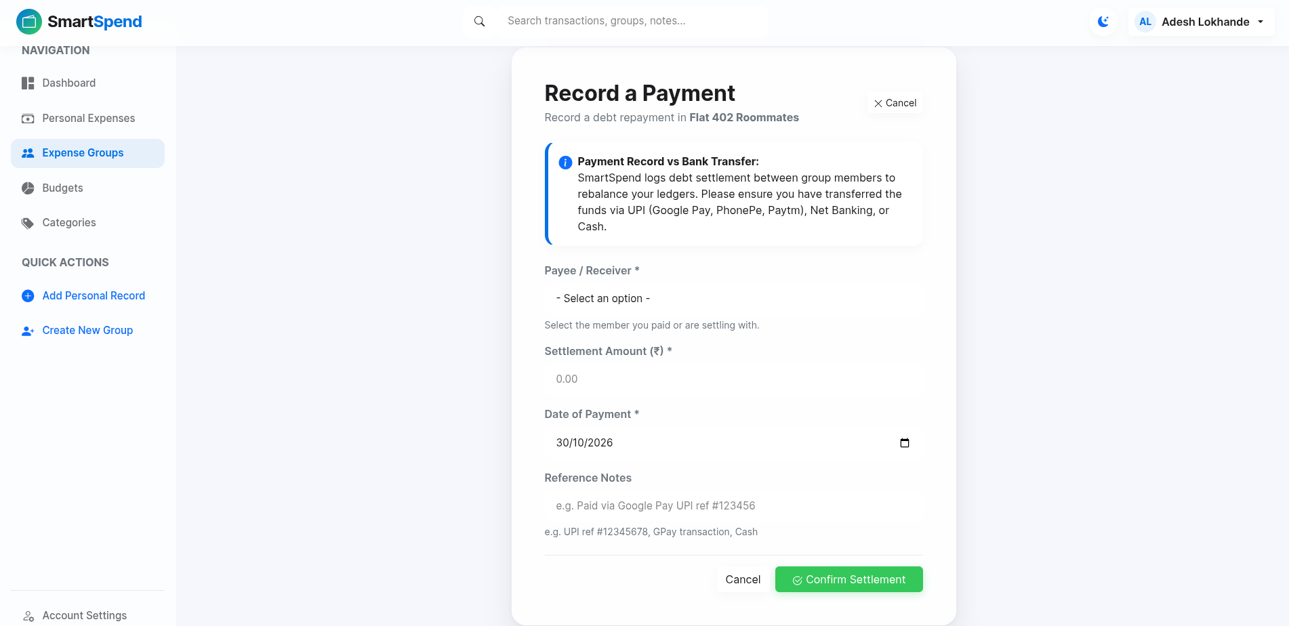
This module calculates outstanding balances based on recorded payments and individual expense shares. It also allows users to maintain settlement records when payments are made between group members.
7. Dashboard and Analytics
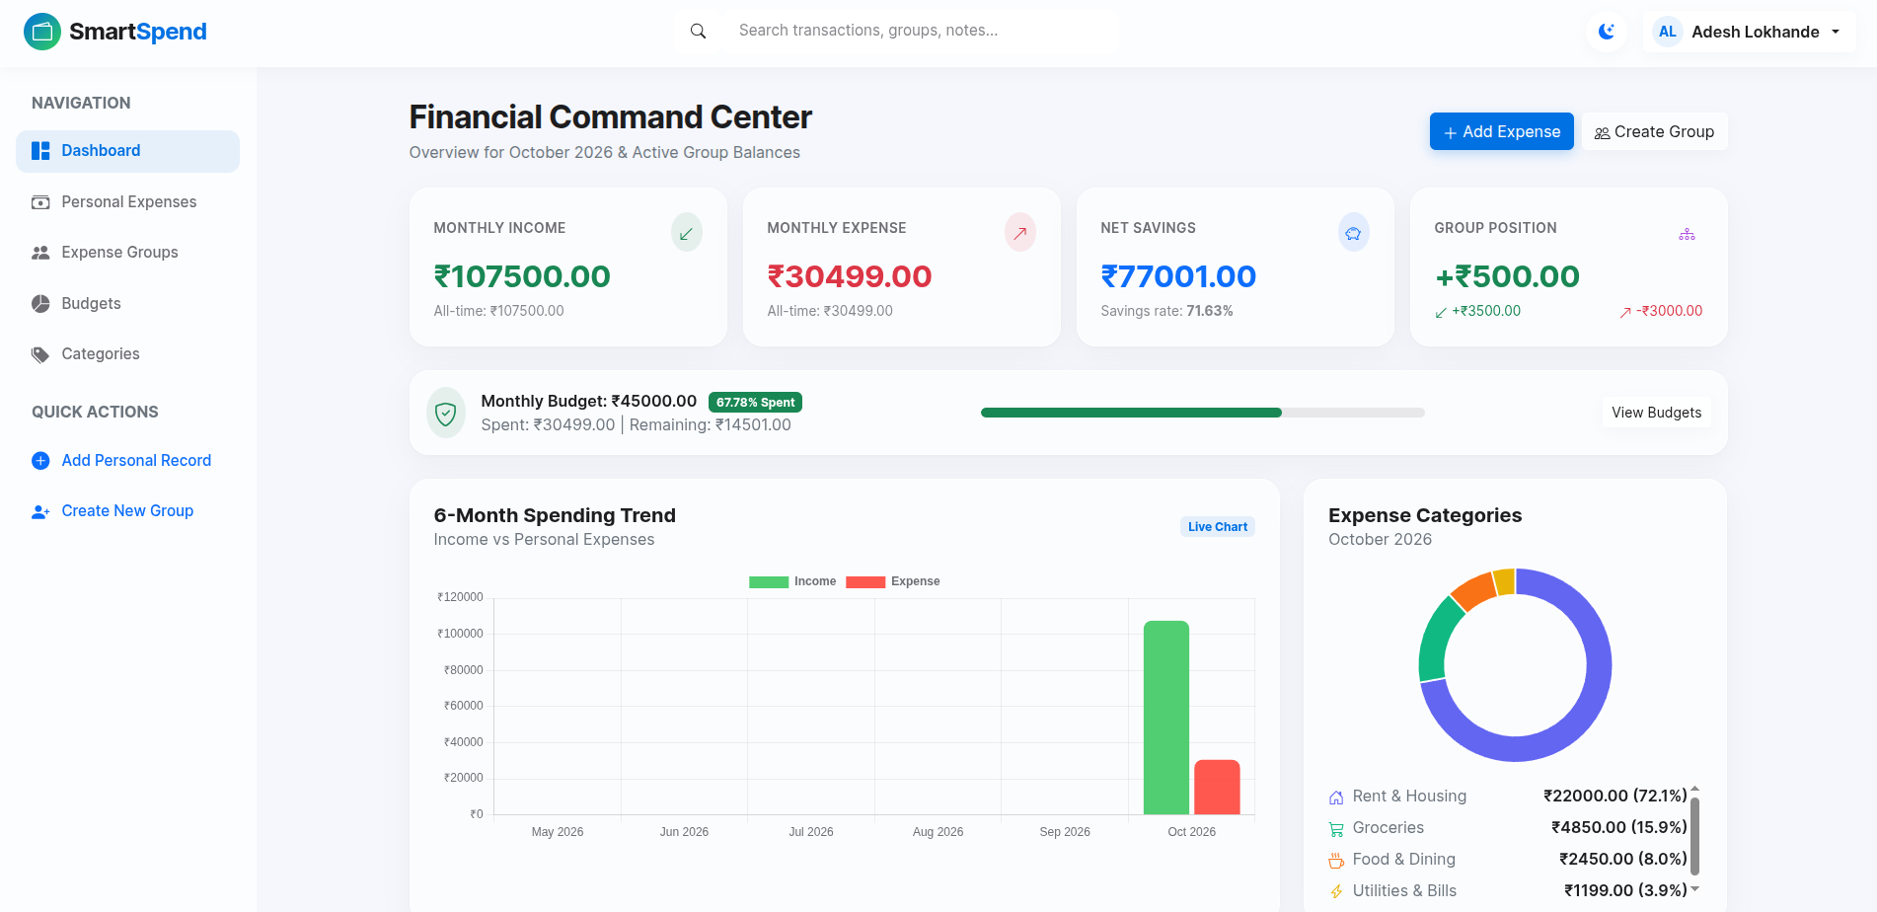
The dashboard presents summarised financial information in an organised format. Chart.js is used to display relevant financial information through graphical representations.
8. Budget Management
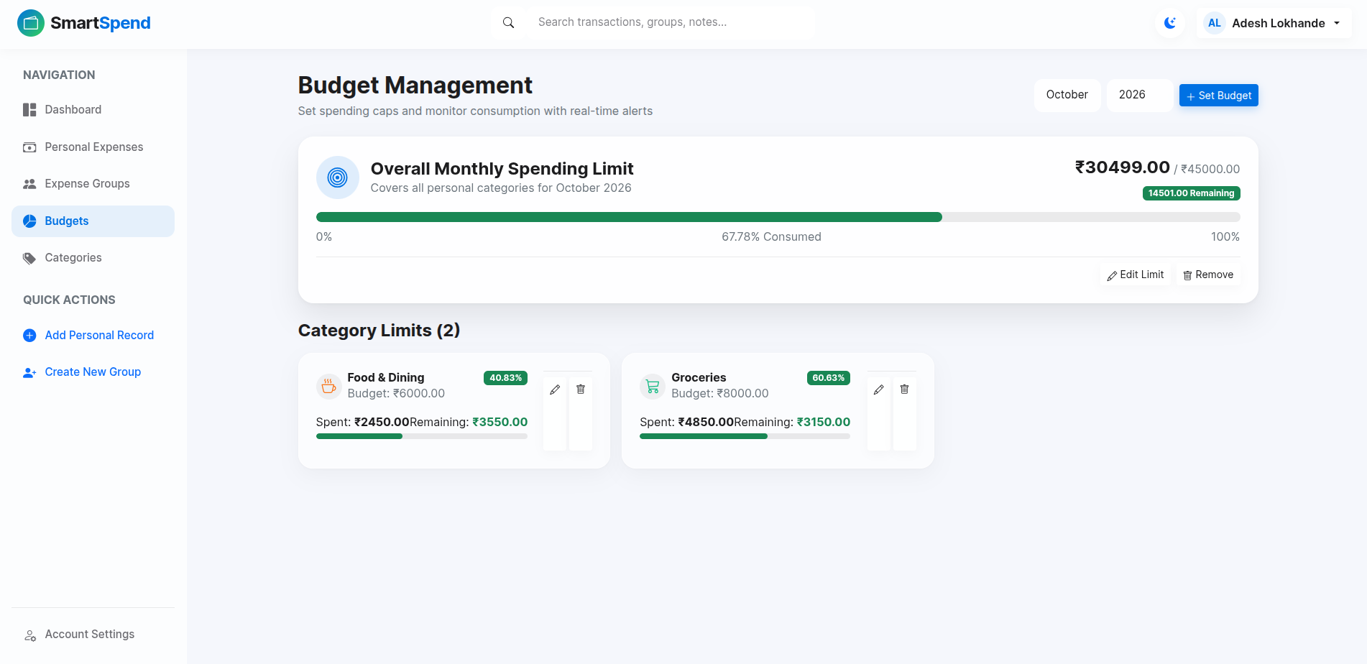
This module allows users to define spending budgets and monitor their expenses against predefined limits. It helps users maintain better control over their expenditure.
9. Search and Filtering
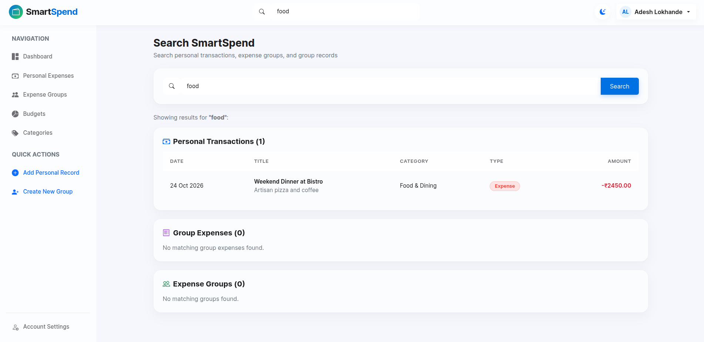
Search and filtering facilities help users locate specific transactions and retrieve relevant expense information without manually examining every record.
10. Administrative and Security Management
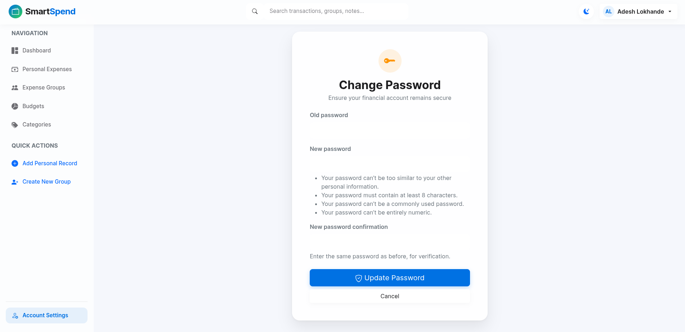
This area supports administrative operations and access control. Security mechanisms are used to protect application data and restrict unauthorised access.

4.1.2 User Interface Implementation
The SmartSpend interface follows a modern design approach inspired by Apple's Liquid Glass concept. It uses translucent components, background blur effects, glass-like cards, and organised layouts to create a consistent visual experience.
Bootstrap 5 supports responsive layouts, while CSS3 and JavaScript provide additional styling and interactive behaviour.
The application provides Dark Mode and Light Mode options to allow users to select their preferred appearance. The responsive interface is designed to support different screen sizes, including desktops, tablets, and mobile devices.

4.1.3 Database Implementation
The database layer stores and manages the information required by the application. MySQL is used as the primary relational database, with SQLite supported as an alternative configuration.
The database maintains structured information related to users, personal expenses, groups, group memberships, shared expenses, expense shares, budgets, and settlements.
Django's database management facilities are used to perform data operations and maintain relationships between application components.

4.2 TESTING AND SIMULATION
Testing is performed to verify whether the developed application behaves according to its specified requirements. It helps identify functional errors, calculation problems, and unexpected application behaviour.
SmartSpend requires testing of both individual modules and integrated operations.
The major testing activities include:
- Functional Testing: Verifies registration, login, expense management, group creation, budget management, and settlement operations.
- Integration Testing: Checks whether different modules work correctly together.
- Calculation Testing: Verifies equal, custom, and percentage-based expense distribution and balance calculations.
- Security Testing: Examines authentication, authorisation, input validation, and protection against unauthorised access.
- Interface Testing: Checks navigation, responsiveness, visual consistency, and theme switching.
Simulation scenarios are also used to examine expense-sharing calculations. For example, an expense of ₹4,000 shared equally among four participants should result in an individual share of ₹1,000. Such scenarios help verify the correctness of the expense-splitting logic.
The testing process helps evaluate the major functionalities of SmartSpend and identify areas requiring improvement. Actual testing outcomes are documented separately in the Results and Discussions chapter.

CHAPTER 5: RESULTS AND DISCUSSIONS

5.1 INTRODUCTION
The SmartSpend – Smart Expense Manager and Splitwise Clone project was developed to provide an integrated platform for managing personal expenses and shared group expenses. The main purpose of the application is to simplify financial record management, improve expense visibility, and reduce the difficulties involved in calculating shared payments among multiple users.
This chapter discusses the outputs produced by the developed system and evaluates its major functionalities. The results are examined from the perspective of expense management, group expense splitting, balance calculation, settlement management, budgeting, and user interface usability.
The application provides separate facilities for personal and group-based financial activities. Users can maintain their individual expense records while also participating in groups where expenses can be shared among members. The system combines these features within a single web-based platform.

5.2 RESULTS OF PERSONAL EXPENSE MANAGEMENT
The personal expense management module allows users to maintain records of their individual financial transactions. Users can add expense details, enter relevant information, and view previously recorded transactions. This functionality helps users maintain an organised record of their daily spending.
The expense records provide a structured way to understand where money is being spent. Instead of maintaining separate handwritten records or scattered digital entries, users can manage their expenses through a common interface.
The dashboard and expense listing interface help users access their financial information conveniently. The availability of organised expense records also supports better financial awareness and makes it easier to review previous spending activities.

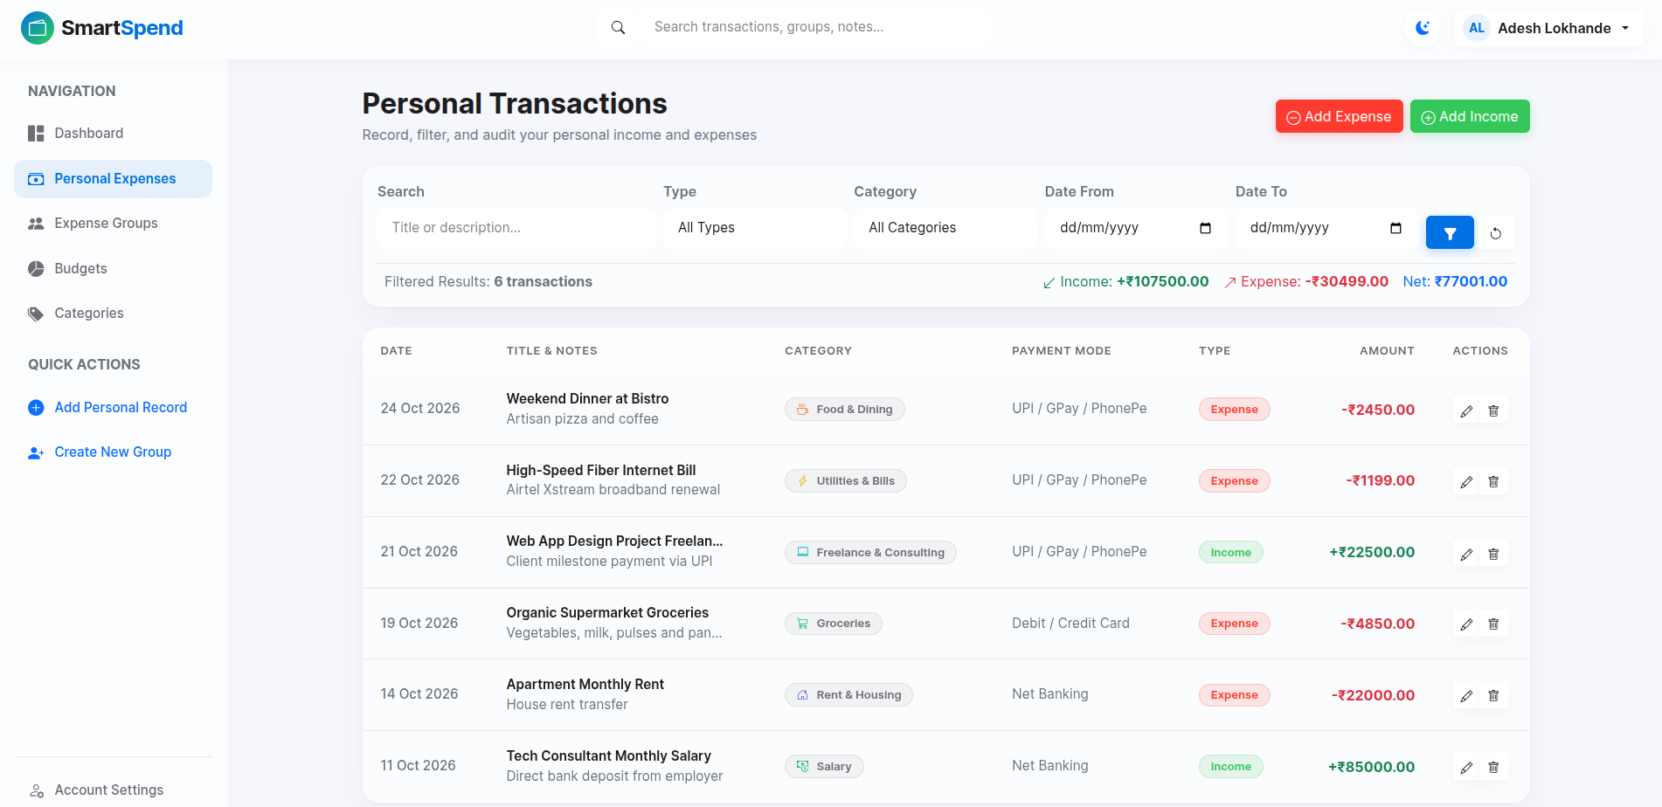

5.3 RESULTS OF GROUP EXPENSE MANAGEMENT
The group expense management module is designed to handle expenses shared by multiple users. Users can create groups, manage group members, and record expenses associated with a particular group.
This functionality is useful in situations where several individuals share financial responsibilities, such as travelling, living together, organising events, or managing common household expenses.
When an expense is recorded within a group, the application provides options for distributing the amount among the relevant members. The system supports different splitting methods, including equal splitting, custom amounts, and percentage-based splitting.
For example, consider a group expense of ₹4,000 shared equally among four members. The amount payable by each member is calculated as:
Total Expense = ₹4,000
Number of Members = 4
Individual Share = ₹4,000 / 4 = ₹1,000
Therefore, each member's share is ₹1,000. This example demonstrates how the expense-splitting functionality can simplify the distribution of shared expenses.
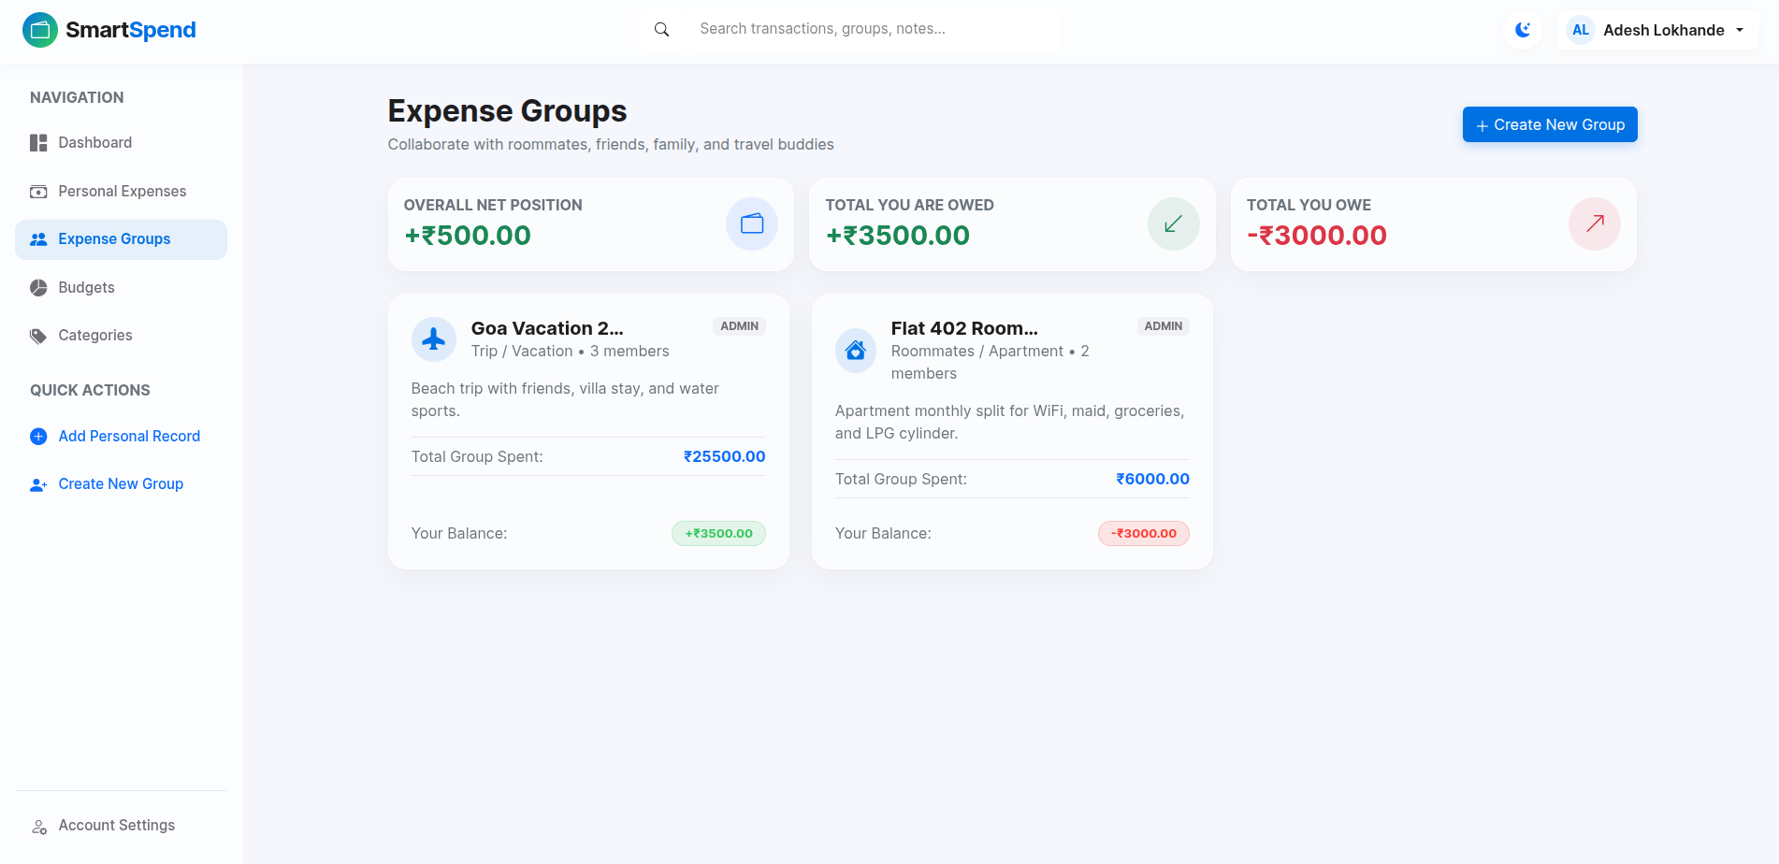

5.4 RESULTS OF BALANCE CALCULATION AND SETTLEMENT MANAGEMENT
One of the important functionalities of SmartSpend is the management of balances between group members. When group expenses are recorded and distributed, the application maintains the financial information required to understand the amount owed by or payable to each member.
The balance management functionality helps users identify pending financial responsibilities within a group. It reduces the need for manually calculating individual contributions after every shared transaction.
The settlement module provides a way to record payments made between group members. When a member settles an outstanding amount, the corresponding settlement information can be maintained in the application.
For example, if one member pays an expense on behalf of other members, the application can represent the resulting financial obligations according to the selected splitting method. This makes the process of understanding and managing shared expenses more organised.
The accuracy of balance and settlement information depends on correct expense entries, member details, and splitting values. Therefore, these operations should be tested with different group sizes and expense amounts.
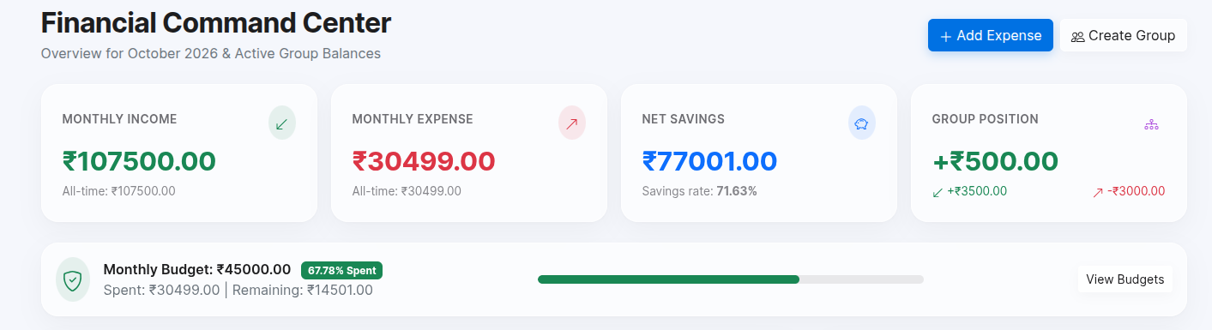

5.5 RESULTS OF BUDGET MANAGEMENT
The budget management module helps users define spending limits and monitor their expenses against those limits. Budgeting is an important part of personal financial management because it allows individuals to plan their spending and maintain better control over their available funds.
Through this module, users can create budgets and review their spending in relation to the defined limits. The information helps users understand whether their expenses are within the planned budget or have exceeded the specified amount.
The budget functionality complements the personal expense management module. While expense management focuses on recording transactions, budgeting provides a planned financial limit against which spending can be evaluated.
The usefulness of this module depends on the accuracy and completeness of the recorded expense information.
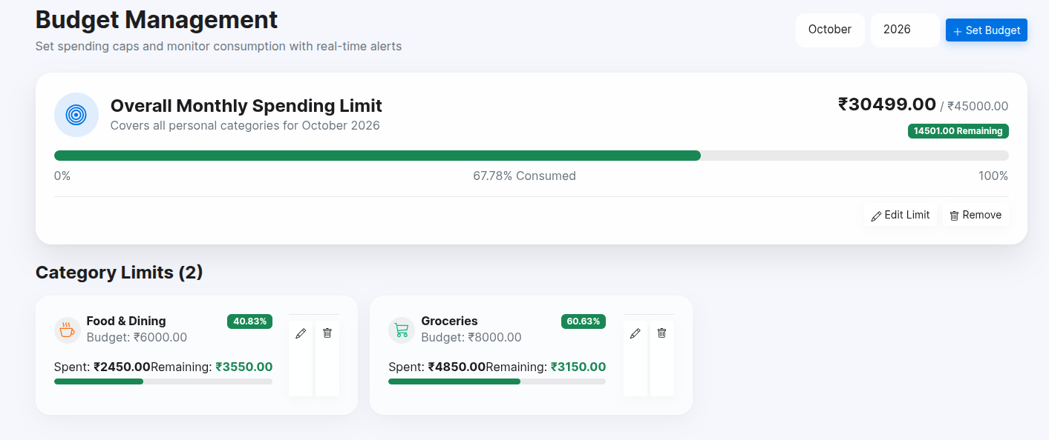

5.6 USER INTERFACE AND THEME RESULTS
SmartSpend uses a modern user interface inspired by the Apple Liquid Glass design approach. The interface uses glass-like visual elements, organised content sections, and a consistent layout to present information clearly.
The application includes Dark Mode and Light Mode options. This allows users to select a visual appearance according to their preference and viewing environment.
The responsive interface is designed to provide a usable experience across different screen sizes, including desktop, tablet, and mobile devices. Navigation elements, forms, tables, and dashboard components are organised to support convenient interaction.
The visual design is an important part of the overall application because users regularly interact with expense forms, financial summaries, group details, and other information. A consistent interface helps improve the overall user experience.
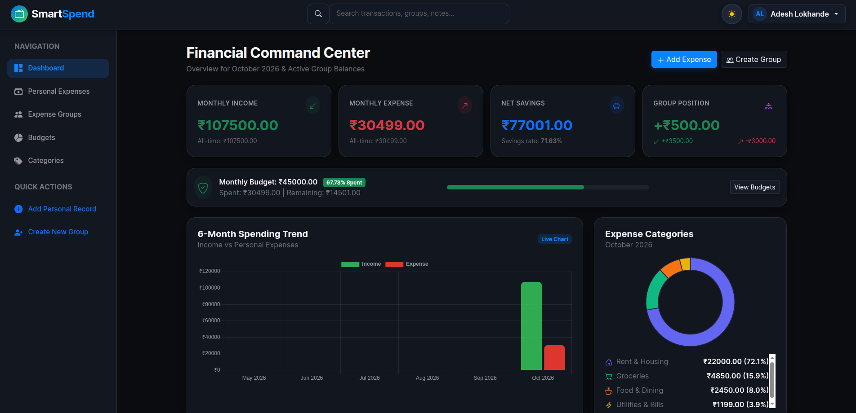

5.7 DISCUSSION AND OVERALL EVALUATION
The developed SmartSpend application combines personal expense management and group expense splitting within one platform. Its major advantage is that users do not need separate applications for maintaining individual expenses and managing shared financial activities.
The personal expense module supports organised transaction records, while the group management module provides facilities for handling shared expenses. Different splitting methods offer flexibility when distributing expenses among members. Balance calculation and settlement management further support the tracking of financial responsibilities.
The budget management module adds another dimension by allowing users to compare their spending with planned limits. The dashboard brings important financial information together and provides a central point for accessing application features.
The application's interface also contributes to its usability through a responsive layout and theme selection. However, the quality of the results depends on correct user input, proper configuration, and reliable application behaviour.
The system should be evaluated using practical test cases covering registration, login, expense creation, group creation, expense splitting, balance updates, settlements, and budget operations. Testing should also include invalid inputs and boundary conditions to identify possible errors.
Overall, SmartSpend demonstrates how personal financial tracking and shared expense management can be integrated into a single web-based application. It provides a structured approach to recording expenses, distributing shared costs, monitoring balances, and managing budgets.
The results indicate that the project fulfils its intended functional objectives as a combined expense management platform. Further improvements can be considered to enhance usability, performance, accessibility, and the range of financial management capabilities.

CHAPTER 6: SUMMARY AND CONCLUSION

6.1 SUMMARY
SmartSpend – Smart Expense Manager and Splitwise Clone is a web-based application developed to simplify personal expense tracking and shared group expense management. The project focuses on providing a common platform where users can record individual expenses, manage group activities, divide shared expenses, monitor balances, and maintain budgets.
In traditional expense management methods, individuals often depend on handwritten records, spreadsheets, or separate applications to maintain their financial information. Managing shared expenses among multiple people can become complicated, particularly when several members contribute different amounts or participate in different transactions. Manual calculations may also lead to confusion and errors.
SmartSpend addresses these challenges by integrating personal and group expense management functionalities into a single application. It provides an organised interface through which users can maintain financial records and access relevant information.
The project includes several major modules. The authentication and profile management module provides facilities for user account access and profile management. The personal expense management module allows users to record and manage their individual transactions.
The group management module supports the creation and management of groups and their members. The group expense management module allows users to record expenses associated with a particular group. The expense-splitting functionality supports equal, custom amount, and percentage-based distribution methods.
The balance and debt calculation functionality helps users understand financial responsibilities among group members. The settlement management module provides facilities to record payments made towards outstanding balances. These features make shared expense management more structured and convenient.
The budget management module allows users to define spending limits and review expenses against their planned budgets. The dashboard provides a central interface for accessing important financial information and application functionalities.
The application also incorporates a modern user interface inspired by the Apple Liquid Glass design approach. It provides Dark Mode and Light Mode options and follows a responsive design approach to support different screen sizes.
The project demonstrates the practical application of web development technologies in solving common financial management problems. It combines user interaction, data management, expense calculations, and interface design into one integrated system.

6.2 CONCLUSION
The development of SmartSpend successfully demonstrates an integrated approach to personal expense management and group expense splitting. The project was designed to reduce the difficulties associated with maintaining financial records and calculating shared expenses manually.
By providing separate facilities for personal and group expenses, the application supports different financial management requirements within a single platform. Users can maintain their individual transactions, create groups, record shared expenses, and distribute amounts using different splitting methods.
The balance and settlement functionalities further improve the management of shared financial responsibilities. They help users understand outstanding amounts and maintain records of settlements between group members. The budget management functionality supports planned spending by allowing users to compare their expenses with defined budget limits.
Another important aspect of the project is its user interface. The responsive layout and Dark Mode and Light Mode options provide flexibility in how users interact with the application. The overall design aims to make financial information easier to access and understand.
The project also provides practical experience in developing a database-driven web application. It involves important concepts such as authentication, data storage, application logic, user interface development, expense calculations, and integration of different modules.
SmartSpend can be considered a useful solution for individuals and groups who need an organised way to manage personal and shared expenses. Although the application provides essential expense management functionalities, its effectiveness depends on accurate data entry and proper usage.
In conclusion, the project fulfils its intended objective of combining personal expense tracking and group expense management in one web-based application. It provides a foundation that can be extended with additional financial tools and advanced capabilities in the future.

6.3 SCOPE FOR FUTURE WORK
Although SmartSpend provides essential features for personal and group expense management, several improvements can be considered to extend its functionality and usefulness.
6.3.1. Mobile Application Development
A dedicated Android and iOS application can be developed to provide convenient access to expense management features through mobile devices. This would allow users to manage their expenses more easily while travelling or performing daily activities.
6.3.2. Advanced Financial Analytics
The dashboard can be enhanced with additional analytical features, including monthly spending comparisons, category-wise expense analysis, and long-term financial trends. These features could help users understand their spending habits more effectively.
6.3.3. Payment Gateway Integration
Integration with digital payment services could simplify the settlement process. Users may be able to initiate payments through supported payment platforms instead of
manually completing transactions outside the application.
6.3.4. Multi-Currency Support
Multi-currency functionality could be introduced to support users who travel internationally or manage expenses in different currencies. Currency conversion could help calculate shared expenses across different regions.
6.3.5. Data Backup and Recovery
A secure backup and recovery mechanism could be introduced to protect financial records against accidental deletion or unexpected system failures. This would improve data availability and reliability.
6.3.6. Advanced Security Features
Additional security mechanisms, such as multi-factor authentication, improved session management, and enhanced access controls, could be implemented to strengthen user account protection and data security.
6.3.7. Improved Reporting and Export Facilities
Future versions could include downloadable financial summaries in formats such as PDF and Excel. These reports could help users maintain offline records and analyse their financial activities.
6.3.8. Intelligent Expense Analysis
Artificial intelligence and machine learning techniques could be explored to analyse spending patterns and provide personalised budgeting suggestions. Such features could help users identify unnecessary spending and improve financial planning.
These future enhancements could make SmartSpend a more comprehensive financial management platform. They would extend the existing system while maintaining its primary objective of simplifying personal and shared expense management

REFERENCES

Research Papers and Publications

[1] B. Savitha and I. T. Hawaldar, “What Motivates Individuals to Use FinTech Budgeting Applications? Evidence from India During the COVID-19 Pandemic,” Cogent Economics & Finance, vol. 10, no. 1, Article 2127482, 2022. DOI: https://doi.org/10.1080/23322039.2022.2127482

[2] M. More, R. H. Tapadia, T. Tare, T. Phalke, S. Tayde, P. Tayde, and S. Tarade, “SpendWise – An Innovative Expense Tracking Webapp for Students,” International Journal of Innovative Research in Technology (IJIRT), vol. 10, issue 6, November 2023.

[3] S. Jha, P. Jha, R. Singh, S. Kumari, and Lokesh, “Design and Implementation of a Web-Based Expense Tracker System for Personal Finance Management,” International Journal of Research in Engineering & Science, 2025. DOI: https://doi.org/10.5281/zenodo.18066941

[4] M. Jain, N. Tenguria, R. Sharma, and S. Gupta, “Apportion – The Bill Split,” International Research Journal of Modernisation in Engineering Technology and Science, vol. 5, issue 4, April 2023. DOI: https://doi.org/10.56726/IRJMETS36004

[5] “Finexa: A Personal Finance Management Web Application for Expense Tracking and Budgeting,” in 2026 6th Biennial International Conference on Nascent Technologies in Engineering (ICNTE), 2026. DOI: https://doi.org/10.1109/ICNTE66387.2026.11437467

Technical Documentation and Online Resources

[6] Django Software Foundation, “Django Documentation.” Available at: https://docs.djangoproject.com/

[7] Oracle Corporation, “MySQL Reference Manual.” Available at: https://dev.mysql.com/doc/refman/8.4/en/

[8] Bootstrap Team, “Bootstrap Documentation.” Available at: https://getbootstrap.com/docs/5.3/

[9] Chart.js Contributors, “Chart.js Documentation.” Available at: https://www.chartjs.org/docs/latest/

[10] Splitwise, “How Do I Use Splitwise?” Available at: https://kb.splitwise.com/getting-started/how-do-i-use-splitwise

[11] Splitwise, “What Are Different Ways I Can Split an Expense?” Available at: https://kb.splitwise.com/balances-and-expenses/what-are-different-ways-i-can-split-an-expense

[12] Mozilla Developer Network (MDN), “JavaScript Guide.” Available at: https://developer.mozilla.org/en-US/docs/Web/JavaScript/Guide

[13] Mozilla Developer Network (MDN), “HTML: HyperText Markup Language.” Available at: https://developer.mozilla.org/en-US/docs/Web/HTML

[14] Mozilla Developer Network (MDN), “CSS: Cascading Style Sheets.” Available at: https://developer.mozilla.org/en-US/docs/Web/CSS

Development Tools

[15] Google, “Google Antigravity – AI-Powered Development Environment.” Available at: https://antigravity.google/

Note: Online documentation and resources were referred to for understanding the technologies, frameworks, and development concepts used in the project.

Details of Paper/s Published

Copyright Certificate

NPTEL Elite Certificate

Plagiarism Report

Grammarly Report

Photo Gallery

Bibliography

